what is ECU?

An electronic control unit (ECU) is a small device in a vehicle’s body that is responsible for controlling a specific function.

Each ECU typically contains a dedicated chip that runs its own software or firmware, and requires power and data connections to operate.
An ECU receives inputs from different parts of the vehicle, depending on its function. For example, a door lock ECU would receive input when a passenger pushes the door lock/unlock button on a car door or on a wireless key fob. An airbag ECU would receive inputs from crash sensors and from sensors that detect when someone is sitting in a particular seat. And an automatic emergency braking ECU would receive inputs from forward-facing radars that detect when the vehicle is approaching an obstacle too quickly.
The ECU would then communicate to actuators to perform an action based on the inputs. In our examples, the door lock ECU would activate an actuator that locks or unlocks the corresponding door. The airbag ECU would choose which airbags to deploy, depending on the location of the passengers, and then direct the actuators to deploy them. And the automatic emergency braking ECU would engage the brakes to prevent a collision.

ECUs can be utilized for the transmission, ABS, air conditioning, body functions, and lighting control, engine, airbags, or any other system in a vehicle. Some vehicles use a powertrain control module, which combines many ECUs into a single unit (PCM). These units can be advantageous since they house numerous modules in one area, but they can also be disadvantageous because they require longer lines to reach the component they control.

https://www.aptiv.com/en/insights/article/what-is-an-electronic-control-unit

vehicles having multiple ECU they are divided on what tasks they perform. Some of these types are as follows.
- Engine Control Module
With its sensors, the ECM ensures the amount of fuel and ignition timing necessary to get the most power and economy out of the engine.
- Brake Control Module
Used in vehicles with ABS, the BCM makes sure that the wheels are not skidding and determine when to trigger braking and let go of the brake to ensure the wheels don’t lock up.
- Transmission Control Module
Used on an automatic vehicle, the TCM ensures you get the smoothest shifts possible by assessing the engine RPM and acceleration of the car.
- Telematic Control Module
Another one with the same abbreviation this TCU ensures the car onboard services are up and running. It controls the satellite navigation and Internet and phone connectivity of the vehicle.
- Suspension Control Module
Present in Cars with active suspension systems, the SCM ensures the correct ride height and optimal changes to suspension depending on the driving condition.
Why do cars have multiple ECUs (Electronic Control Units) instead of really one very powerful multicore ECU which can perform all functionality?

One reason is that, for a specific model of car, there can be various engine and gearbox variants.
So, while the same ECU can be used for stuff like the ABS and the instrument cluster, it's often easier to have a separate ECU for each engine and another for each gearbox.
This way, if changes are made to one it won't adversely affect the others and, should someone switch out the engine or gearbox for a slightly different one, the engine or gearbox ECU can be swapped much more cheaply than a monolithic one could be.
Want to add a feature (e.g. ABS) to a base model car? - much easier if you don't have to have the car's brain reprogrammed and can simply add another ECU that already knows how to work ABS.
Granted, you should be able to reprogram any of the above with new parameters but it is possible that changing a component may involve additional wiring for sensors not present on the original.
This is why CANbus and similar systems are so good, as long as all the modules that need to be are aware of the modules fitted, it works as a whole like an integrated system.
The other reason is tou don't really want a single point of failure in a chunk of metal designed to travel at high speeds - if the ABS computer fails then it should not take the engine and gearbox with it (equally, you don't want to lose brakes should the gearbox stop shifting).

https://www.quora.com/Why-do-cars-have-multiple-ECUs-Electronic-Control-Units-instead-of-really-one-very-powerful-multicore-ECU-which-can-perform-all-functionality

Centralized ECU System vs Multiple ECU System
Vehicle ECU are small computers in themselves which are essential in supporting various product features.
Based on the business objectives and other technical considerations, one can design a system architecture either with single ECU or one with multiple units. We will discuss details of both these designs.

How Single ECU System Architecture Works

Typically, in a single ECU scenario, there is a central Body Control Unit that does all the hard work. It is directly connected to various sensors, collects the required information from sensors and CAN network, does the processing and implements necessary action. This works best when there are not too many sensors are integrated in your product design.

The algorithms required to process the vehicle parameters are ported in the processor of this central control unit. The central Body control Module (BCM) is connected to sensors through the harness (wires). Functions like DC to DC conversion, drivetrain, lamp load etc. are handled by the main unit.

Pros:
- As a single ECU is at work, the developers need to devote lesser time for testing the units.
- Fewer Third-party licenses are involved.
- The fault can be easily located because of the centralized design of the architecture.
- Lesser number of ECUs leads to reduced time-to-market and design cost.

Cons:
- Direct connection of a number of Sensors with the central body control unit translates into a complicated set of harnesses which creates complexity.
- Single ECU also means a bigger board that may take up a lot of space.
- A back-up unit (Redundant system) is required as a fault in the Main ECU can have a far-reaching impact. This again translates into cost overhead.
How a Multiple ECUs Architecture System works
Having a more decentralized architecture, this system has multiple ECUs which are tasked to manage different functions. However, each of them is interfaced with the main control unit, called the body control module.
So there is a separate control unit for powertrain motor control system,CAN input/output, headlight, infotainment system and so on. These ECUs are connected to the respective sensors in order to fetch the required information.
For instance, the infotainment ECU will fetch the wheel speed, engine speed etc. and display them on the screen. Another ECU may read the level of the fuel in the tank and calculate the distance-to-empty using an algorithm.
A separate control unit for different functions helps in de-cluttering the entire system.

Pros:
- Control processor (Main Control Unit) will perform only the computation and this helps in boosting the overall performance of the system.
- Complexity of the harness (wiring) coming to the body control module will be reduced.
- In case of a fault in one control unit, there won’t be an impact on the other units to a large extent.
Cons:
- More ECUs would mean escalated cost, thus making vehicle more expensive.
- Different control units would need to be tested separately; Impact- More turn-around time and increased development cost.
- Several 3rd party licenses may be required, when we use vehicle ECUs from different vendors.

Application of Multi ECU

1.https://ieeexplore.ieee.org/abstract/document/230930/keywords#keywords

2.https://www.jstor.org/stable/44682446

3.https://ieeexplore.ieee.org/abstract/document/5282335/

4.https://www.multiecuscan.net/

5.https://www.embitel.com/blog/embedded-blog/how-automotive-ecu-consolidation-is-powering-the-multi-display-infotainment-system-in-cars

Adaptive autosar application on multi ECU

https://www.elektrobit.com/products/ecu/#:~:text=AUTOSAR%20(AUTomotive%20Open%20System%20ARchitecture,electronic%20control%20unit%20(ECU).

https://www.einfochips.com/blog/autosar-in-automotive-industry/

https://www.autosar.org/fileadmin/user_upload/standards/classic/4-2/AUTOSAR_SWS_ECUStateManager.pdf

https://www.youtube.com/watch?v=WI2hIx2HB-g

https://www.pathpartnertech.com/understanding-automotive-ota-over-the-air-update/

Sealt Belt Remainder system

How we can desing a software for Perticular ECU Function
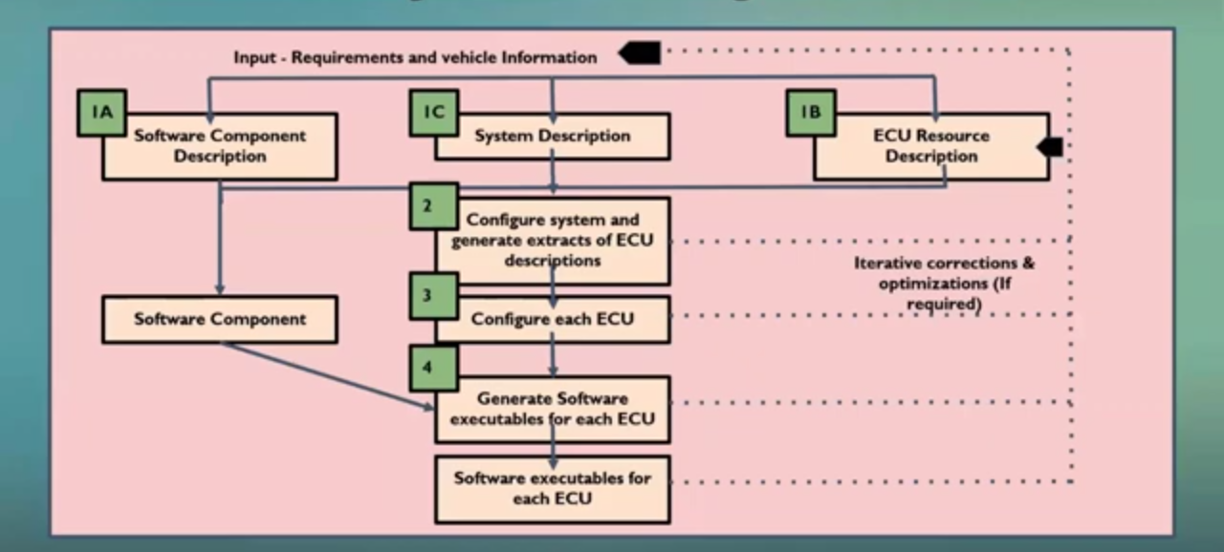

Step1: Software component Description
When we are going to design the software for the Ecu ,first we need to get the input like what are the software components that are required, for example algrorithums ,fault handler,event data recorder.

Step 2: System Description
This specifies what are the set of networking protocal,what are the message we are going to transmit or receive and the number of protocol needed.

Step 3: ECU Resources Description

Step 4:Cofigure system and generate extracts of ECU description and configure Ecu
To design an Ecu we need to configure some of the parameters like what will be the clock,data rate of Ecu ,number of CAN,how many input we are going to give , need to use a tool to generate software components.

Step 5:Generating software executable for each ECU
The last step is to integrate all software components and all configurations.

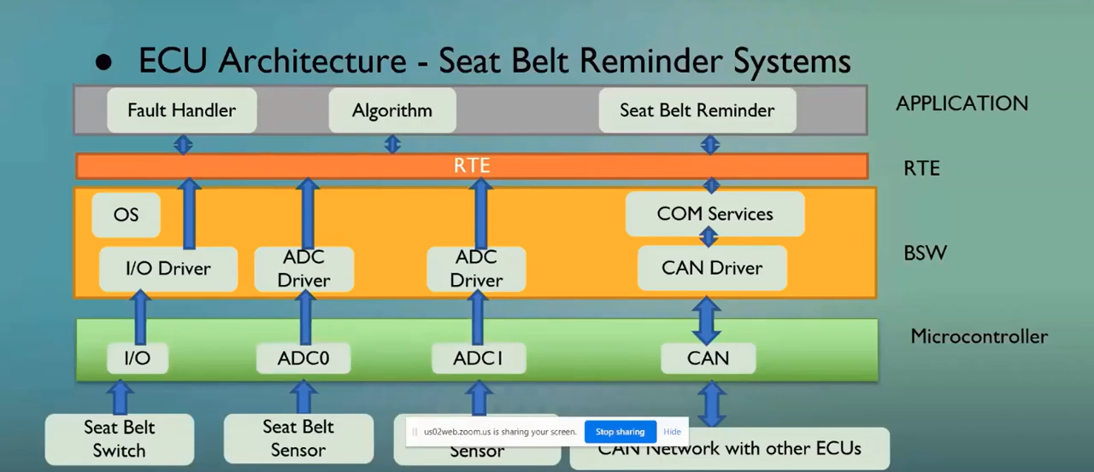
ECU arctitecture for Seat Belt Reminder system

Door Status Software

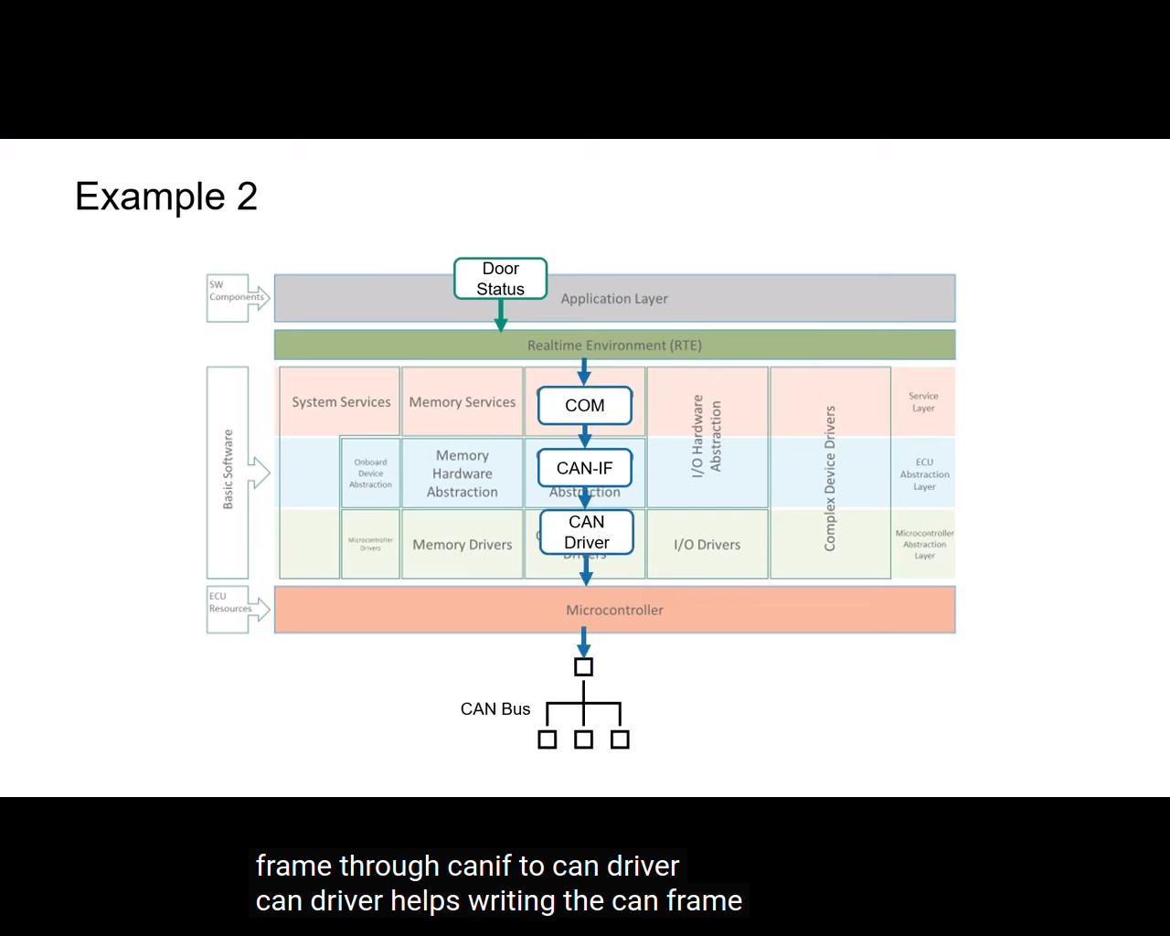

First the door status software component in the application request RTE to send the CAN signal.
This request is routed to communication layer of BSW.
Communication service layer routes the frame throw CAN interface to CAN driver.
CAN driver helps writing the CAN frame into the hardware buffer which is inturn converts the buffer to the electrical signal which are then transmitte through the CAN bus to other Ecus.

https://www.pathpartnertech.com/ecu-startup-sequence-for-beginners/

https://www.pathpartnertech.com/understanding-automotive-ota-over-the-air-update/

https://www.hella.com/techworld/uk/Technical/Car-electronics-and-electrics/Car-airbag-system-3083/

